**Class tutorial 3**

The application interface below is a sample program that allows user to convert the Fahrenheit to Celsius based on the Fahrenheit textbox given by the user in **Figure 1** below**:**

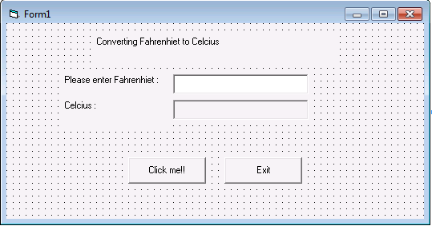

Write the event handlers for Click me!! and Exit, which will take the input from the textbox and convert the value from the textbox to Celsius value and displaying the answer in textbox. The formula and the function to convert Fahrenheit to Celsius is given below:

celsius = (5.0/9.0) * ( fahrenhiet – 32)